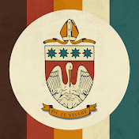
Corpus Christi College Seminary
“Triple C Show”
Every year the regional seminary of Victoria, Corpus Christi College Seminary, hosts a special raffle night. This year the event will be held online and promises to be a fun night of music, comedy and entertainment.
Tune in to the “Triple C Show” this Friday via the Seminary’s YouTube channel. You can also make a donation on the Corpus Christi College website.
Friday, September 17, 2021
7:00pm – 8:00pm
Welcome one and all, to the night you have been waiting for! The Corpus Christi College community has been working very hard over the past few months to prepare a feature length night of entertainment for you to enjoy! Under normal circumstances we would gather together at the Regional Catholic Seminary for the Archdiocese of Melbourne and Tasmania (also incorporating the Dioceses of Sandhurst, Ballarat, Sandhurst, Sale, Adelaide, Darwin and Port Pirie) and the seminarians would give a live performance. In that live performance we hold a raffle that raises money for the seminary community. Since we are now online we have attached a link that you can use to donate money... https://www.corpuschristicollege.org....
Thank-you and Enjoy!

